K BHAVYA SREE
192311388
Question 1: Library Management System – Use Case Diagram
Scenario:
A college library currently maintains book issue and return records manually. Students often face delays while borrowing books because the librarian has to verify availability using registers. Faculty members can reserve books in advance, while librarians can add, update, and remove books from the catalog. Students can search books by title, author, or category. The librarian also calculates overdue fines and generates monthly reports. The college administration wants an automated system that provides faster services and minimizes manual errors. The system should also allow users to log in securely. Notifications should be sent for overdue books. Different users should have different access rights. As a system analyst, identify the actors and their interactions.
Procedure
1. Open Umbrello UML Modeller.
2. Select File → New to create a project.
3. Choose the required UML diagram type.
4. Create a new diagram from the Tree View.
5. Add UML elements (Class, Actor, Use Case, etc.).
6. Place the elements on the workspace.
7. Enter names and details for each element.
8. Connect elements using relationships/associations.
9. Save the diagram using File → Save.
10. Export or print the completed diagram.
Use Case Diagram
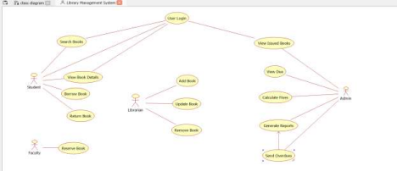1
Class Diagram
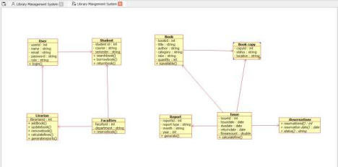
State Diagram
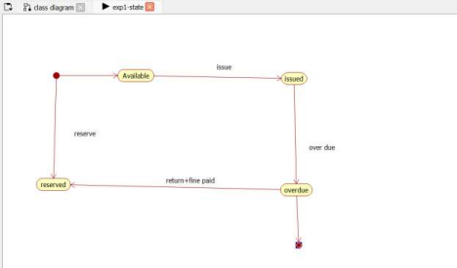Activity Diagram
2
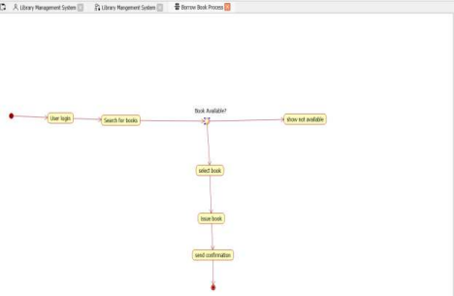Communication Diagram
3
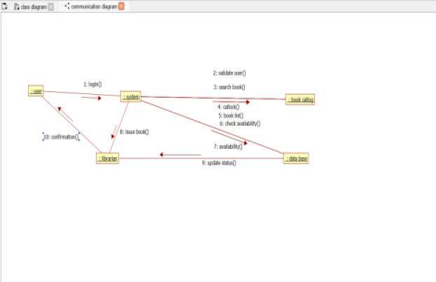Component Diagram
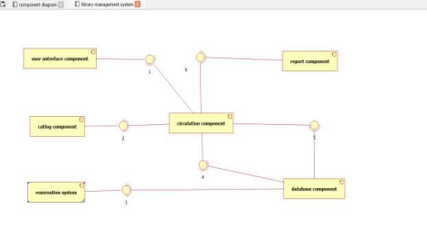Deployment Diagram
4
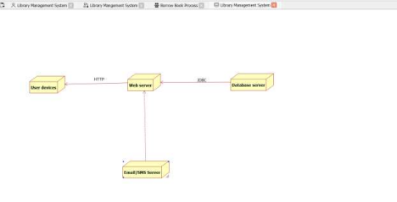
Question 2: Hospital Management System – Class Diagram
Scenario:
5
A multispecialty hospital wants to automate patient management. Patients can register online, schedule appointments, and access medical reports. Doctors diagnose patients and prescribe medicines. Receptionists manage appointments and billing. Pharmacists issue medicines based on prescriptions. The billing department calculates treatment charges and insurance claims. Each patient has a unique medical history. Doctors belong to different departments. The hospital administrator manages staff information. Design the object-oriented structure for this system.
Procedure
1. Open Umbrello UML Modeller.
2. Select File → New to create a project.
3. Choose the required UML diagram type.
4. Create a new diagram from the Tree View.
5. Add UML elements (Class, Actor, Use Case, etc.).
6. Place the elements on the workspace.
7. Enter names and details for each element.
8. Connect elements using relationships/associations.
9. Save the diagram using File → Save.
10. Export or print the completed diagram.
Use Case Diagram
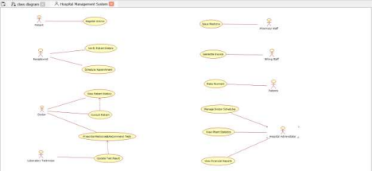Class Diagram
6
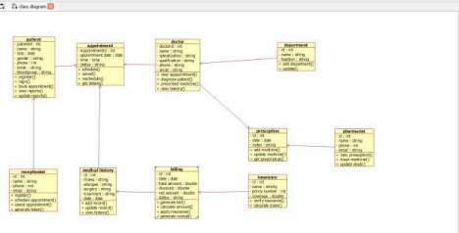Sequence Diagram
7
State Diagram
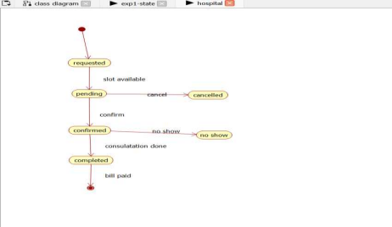
Activity Diagram
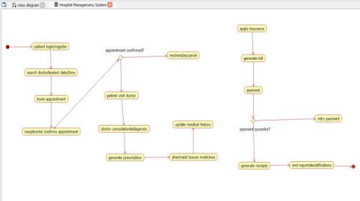8
Communication Diagram
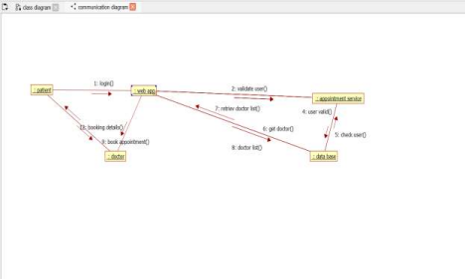Component Diagram
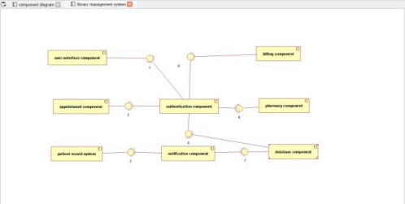9
Deployment Diagram
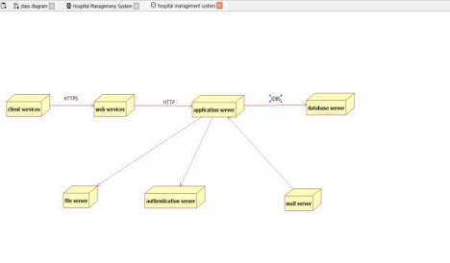10
Question 3: Online Shopping System – Sequence Diagram
Scenario:
An online shopping application allows customers to browse products, add items to a cart, place orders, and make online payments. After successful payment, inventory is updated automatically and an order confirmation email is sent. If payment fails, the customer is prompted to retry. Warehouse staff process confirmed orders for shipping. Customers can track their order status. The payment gateway validates transactions securely. Discounts are applied automatically during checkout. Customer support handles order cancellation requests. The company wants to understand the interaction between system objects during purchase.
Procedure
1. Open Umbrello UML Modeller.
2. Select File → New to create a project.
3. Choose the required UML diagram type.
4. Create a new diagram from the Tree View.
5. Add UML elements (Class, Actor, Use Case, etc.).
6. Place the elements on the workspace.
7. Enter names and details for each element.
8. Connect elements using relationships/associations.
9. Save the diagram using File → Save.
10. Export or print the completed diagram.
Use Case Diagram
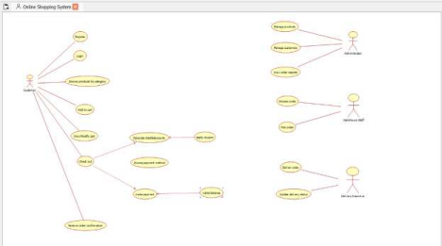11
Class Diagram
Sequence Diagram
12
State Diagram
Activity Diagram
13
Communication Diagram
Component Diagram
14
Deployment Diagram
15
Question 4: ATM Banking System – Activity Diagram
Scenario:
A bank plans to redesign its ATM software. Customers insert their ATM cards, enter PIN numbers, select banking services, perform transactions, and receive printed receipts. Invalid PIN attempts are limited to three. Cash is dispensed only after sufficient balance verification. Every transaction updates the database immediately. Customers can also check account balance and transfer funds. Failed transactions display appropriate error messages. Security and transaction logging are mandatory. The bank requires a workflow representation before implementation.
Procedure
1. Open Umbrello UML Modeller.
2. Select File → New to create a project.
3. Choose the required UML diagram type.
4. Create a new diagram from the Tree View.
5. Add UML elements (Class, Actor, Use Case, etc.).
6. Place the elements on the workspace.
7. Enter names and details for each element.
8. Connect elements using relationships/associations.
9. Save the diagram using File → Save.
10. Export or print the completed diagram.
Use Case Diagram
16
Class Diagram
Sequence Diagram
17
State Diagram
Activity Diagram
18
Communication Diagram
Component Diagram
Deployment Diagram
19
Question 5: Student Course Registration System – State Diagram
Scenario:
A university provides an online course registration portal. Students first create accounts and then select available courses. Registration remains pending until fee payment is completed. Once payment is verified, registration becomes confirmed. Students may withdraw before the semester starts. Courses may become full if seat limits are reached. Administrators can reopen registration if seats become available. Students receive notifications regarding status changes. The university wants to model the lifecycle of course registration.
Procedure
1. Open Umbrello UML Modeller.
2. Select File → New to create a project.
3. Choose the required UML diagram type.
4. Create a new diagram from the Tree View.
5. Add UML elements (Class, Actor, Use Case, etc.).
6. Place the elements on the workspace.
7. Enter names and details for each element.
8. Connect elements using relationships/associations.
9. Save the diagram using File → Save.
10. Export or print the completed diagram.
Use Case Diagram
20
Class Diagram
Sequence Diagram
21
State Diagram
Activity Diagram
22
Communication Diagram
23
Component Diagram
Deployment Diagram
24
Question 6: Food Delivery Application – Communication Diagram
25
Scenario:
A food delivery application connects customers, restaurants, delivery partners, and payment services. Customers place food orders through the mobile application. Restaurants accept and prepare the orders. Delivery agents receive delivery requests and pick up the prepared food. Online payment confirmation is received before delivery. Customers can track delivery in real time. Restaurants update order preparation status regularly. Delivery partners notify customers upon arrival. Customer feedback is collected after successful delivery. The company wants to visualize object communication.
Procedure
1. Open Umbrello UML Modeller.
2. Select File → New to create a project.
3. Choose the required UML diagram type.
4. Create a new diagram from the Tree View.
5. Add UML elements (Class, Actor, Use Case, etc.).
6. Place the elements on the workspace.
7. Enter names and details for each element.
8. Connect elements using relationships/associations.
9. Save the diagram using File → Save.
10. Export or print the completed diagram.
Use Case Diagram
Class Diagram
26
Sequence Diagram
27
State Diagram
Activity Diagram
28
Communication Diagram
Component Diagram
29
Deployment Diagram
30
Question 7: Railway Reservation System – Package Diagram
Scenario:
A railway reservation portal consists of multiple modules including passenger management, train scheduling, ticket booking, payment processing, cancellation, and reporting. Each module has independent responsibilities but communicates with others when required. Ticket booking depends on seat availability. Payment processing communicates with external banking systems. Reporting collects information from all modules. Administrators manage train schedules and fares. The software team wants to organize system components into logical packages for better maintainability. Proper dependency management is essential.
Procedure
1. Open Umbrello UML Modeller.
2. Select File → New to create a project.
3. Choose the required UML diagram type.
4. Create a new diagram from the Tree View.
5. Add UML elements (Class, Actor, Use Case, etc.).
6. Place the elements on the workspace.
7. Enter names and details for each element.
8. Connect elements using relationships/associations.
9. Save the diagram using File → Save.
10. Export or print the completed diagram.
Use Case Diagram
31
Class Diagram
Sequence Diagram
32
State Diagram
Activity Diagram
33
Communication Diagram
Component Diagram
34
Deployment Diagram
35
Question 8: Smart Parking System – Component Diagram
Scenario:
A smart parking application helps users locate available parking spaces. Sensors detect occupied and vacant slots. The mobile application displays parking availability in real time. The payment module handles online parking fees. Administrators monitor parking statistics through dashboards. The notification service alerts users before parking time expires. Security cameras monitor vehicle movement. Database servers store parking information. External payment gateways process financial transactions. The development team wants to identify software components and interfaces.
Procedure
1. Open Umbrello UML Modeller.
2. Select File → New to create a project.
3. Choose the required UML diagram type.
4. Create a new diagram from the Tree View.
5. Add UML elements (Class, Actor, Use Case, etc.).
6. Place the elements on the workspace.
7. Enter names and details for each element.
8. Connect elements using relationships/associations.
9. Save the diagram using File → Save.
10. Export or print the completed diagram.
Use Case Diagram
36
Class Diagram
Sequence Diagram
37
State Diagram
Activity Diagram
38
Communication Diagram
39
Component Diagram
Deployment Diagram
40
Question 9: E-Learning Management System – Deployment Diagram
Scenario:
A university deploys an online learning platform accessible by students and faculty members. Students attend live classes, download study materials, submit assignments, and take online quizzes. Faculty upload lecture materials and evaluate assignments. The application server hosts business logic while the database server stores user information and academic records. Cloud storage maintains multimedia content. Authentication servers verify user credentials. Internet access connects all users to the system. Network security protects sensitive academic information. The institution wants to visualize hardware deployment.
Procedure
1. Open Umbrello UML Modeller.
2. Select File → New to create a project.
3. Choose the required UML diagram type.
4. Create a new diagram from the Tree View.
5. Add UML elements (Class, Actor, Use Case, etc.).
6. Place the elements on the workspace.
7. Enter names and details for each element.
8. Connect elements using relationships/associations.
9. Save the diagram using File → Save.
10. Export or print the completed diagram.
Use Case Diagram
41
Class Diagram
Sequence Diagram
42
State Diagram
Activity Diagram
43
Communication Diagram
Component Diagram
44
Deployment Diagram
45
Question 10: Hotel Reservation System – Object Diagram
Scenario:
A hotel reservation application manages customers, rooms, reservations, payments, and staff. Customers search available rooms based on dates and room categories. Receptionists confirm bookings after payment verification. Housekeeping updates room availability after cleaning. Managers monitor occupancy reports and revenue statistics. Customers receive booking confirmation messages instantly. Rooms can be reserved, occupied, or under maintenance. Staff information is maintained separately. The management wants to view the runtime instances of objects involved in a booking.
Procedure
1. Open Umbrello UML Modeller.
2. Select File → New to create a project.
3. Choose the required UML diagram type.
4. Create a new diagram from the Tree View.
5. Add UML elements (Class, Actor, Use Case, etc.).
6. Place the elements on the workspace.
7. Enter names and details for each element.
8. Connect elements using relationships/associations.
9. Save the diagram using File → Save.
10. Export or print the completed diagram.
Use Case Diagram
46
Class Diagram
Sequence Diagram
47
State Diagram
Activity Diagram
48
Communication Diagram
Component Diagram
49
Deployment Diagram
50

